**Problem Statement:**

How to secure patient records online and send it privately to the intended party

**Topics:**

In this project, you will be working on a hospital project to send reports online and develop a platform so the patients can access the reports via mobile and push notifications. You will publish the report to an Amazon SNS keeping it secure and private. Your message will be hosted on an EC2 instance within your Amazon VPC. By publishing the messages privately, you can improve the message delivery and receipt through Amazon SNS.

**Highlights:**

1. AWS CloudFormation to create a VPC

2. Connect VPC with AWS SNS

3. Publish message privately with SNS.

**Procedure: -**

* I have the stack which contains the following things:
* **https://github.com/Origamini/YAMLFiles/blob/main/Project3Updated.yaml**
* A VPC and the associated networking resources, including a subnet, a security group, an internet gateway, and a route table.
* An Amazon EC2 instance that is launched into the subnet in the VPC.
* An Amazon SNS topic.
* Two AWS Lambda functions. These functions receive messages that are published to the Amazon SNS topic, and they log events in CloudWatch Logs.
* Amazon CloudWatch metrics and logs.
* 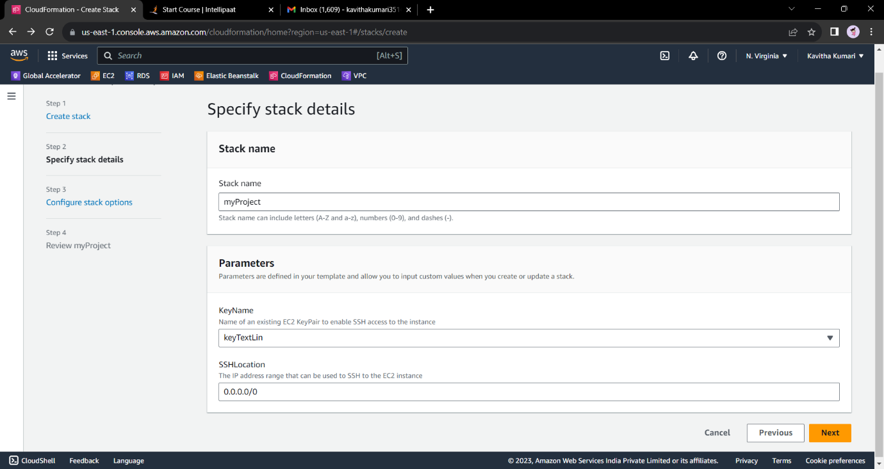An IAM role that allows the Amazon EC2 instance to use Amazon SNS, and an IAM role that allows the Lambda functions to write to CloudWatch logs.
* 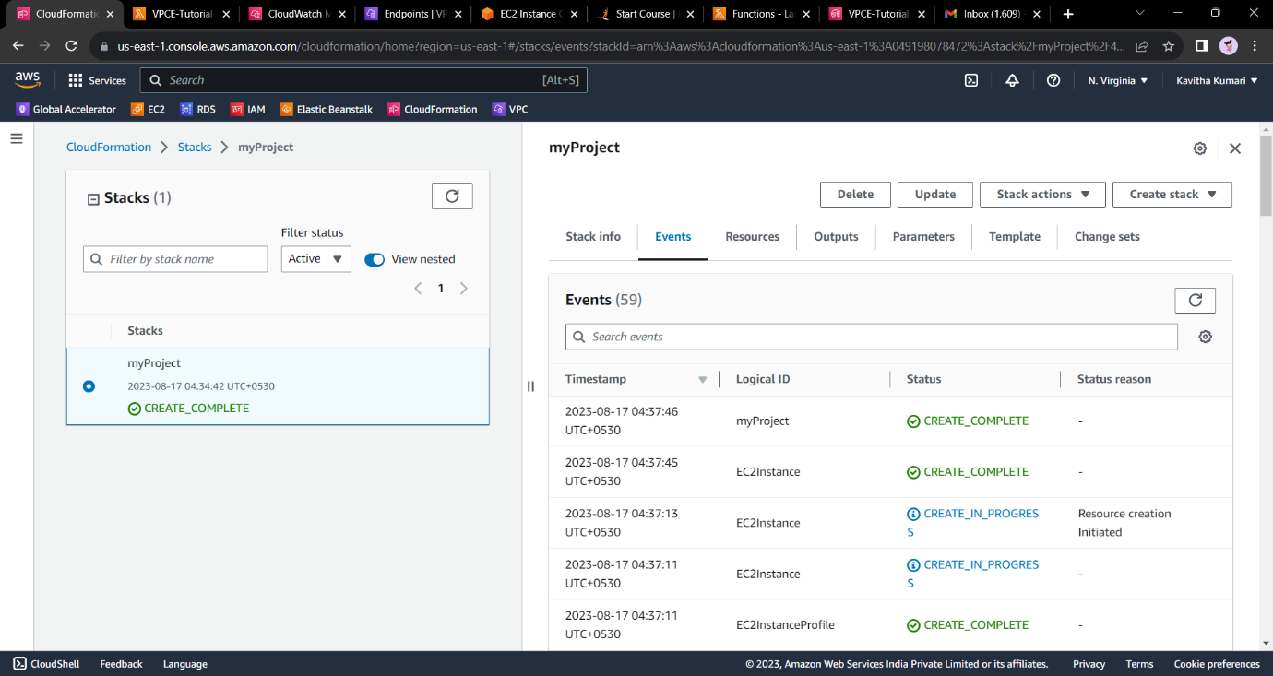Upload the stack and let everything be default and click on next and create the stack.

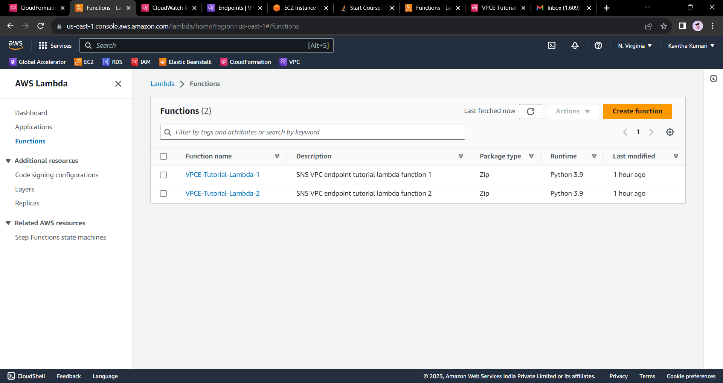

* Now open the Ec2 instance and ssh in to the private instance by the following command.
* ssh -i "keyTextLin.pem" [ec2-user@ec2-100-26-135-115.compute-1.amazonaws.com](mailto:ec2-user@ec2-100-26-135-115.compute-1.amazonaws.com)
* Try to ping google by the following command. “ping google.com”
* Here we will see that we will not be able to connect to the instance but of lack of the endpoint.
* aws sns publish --region us-east-1 --topic-arn arn:aws:sns:us-east-1:049198078472:VPCE-Tutorial-Topic --message "hello"
* If we try to publish a message to the topic by the following command we will fail.

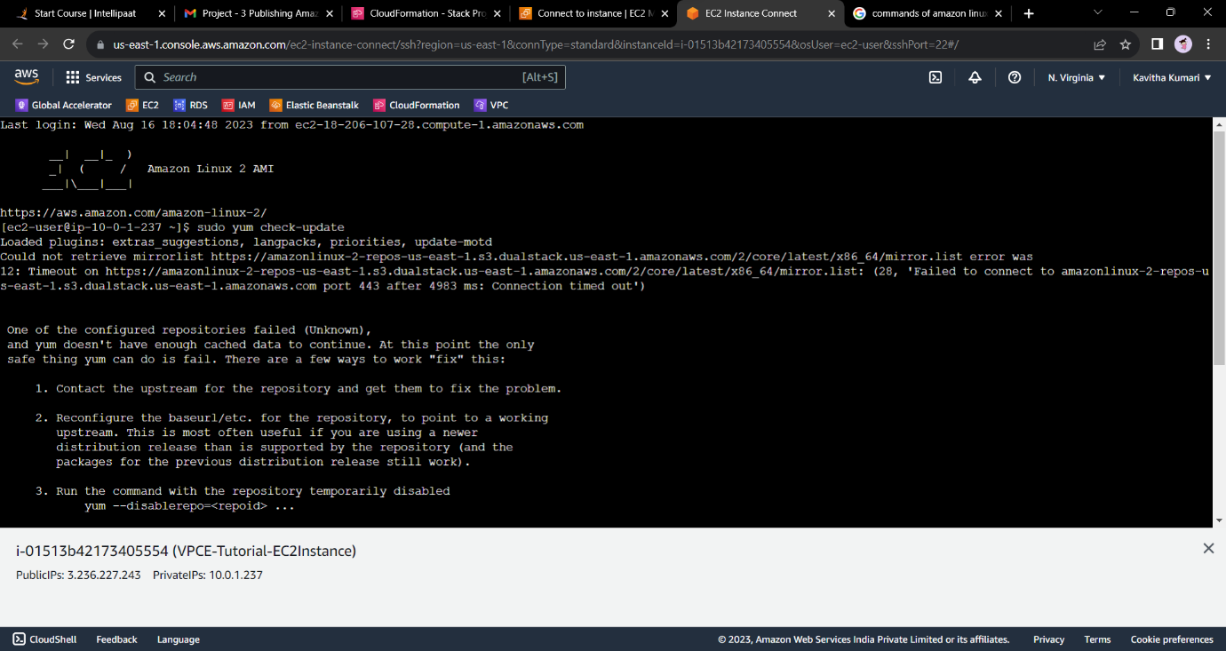

* 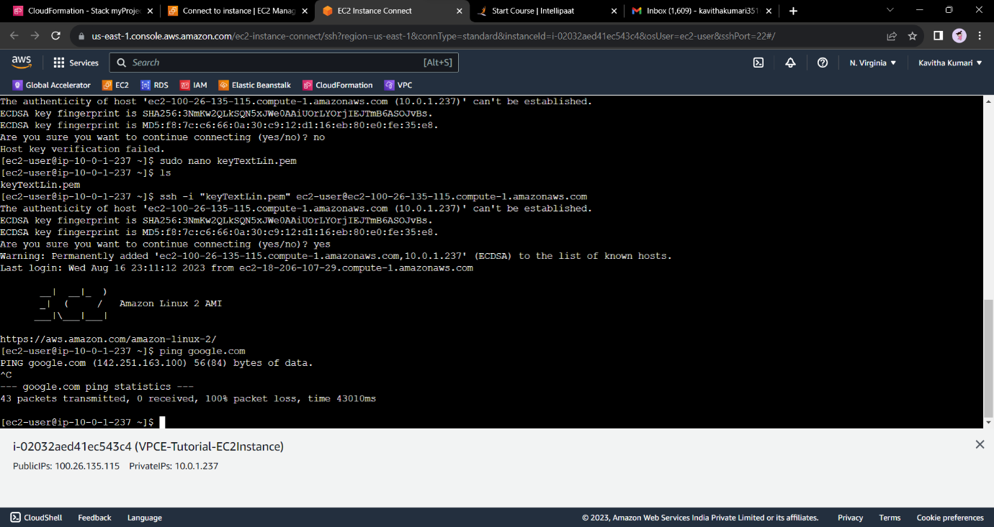Therefore, we will now create an Amazon VPC endpoint for Amazon SNS.
* Open the Amazon VPC console at https://console.aws.amazon.com/vpc/.
* In the navigation menu on the left, choose Endpoints.
* Choose Create Endpoint.
* On the Create Endpoint page, for the Service category, keep the default choice of AWS services.
* For Service Name, choose the service name for Amazon SNS. The service names vary based on the chosen region. For example, if you chose US East (N. Virginia), the service name is com.amazonaws.us-east-1.sns.
* 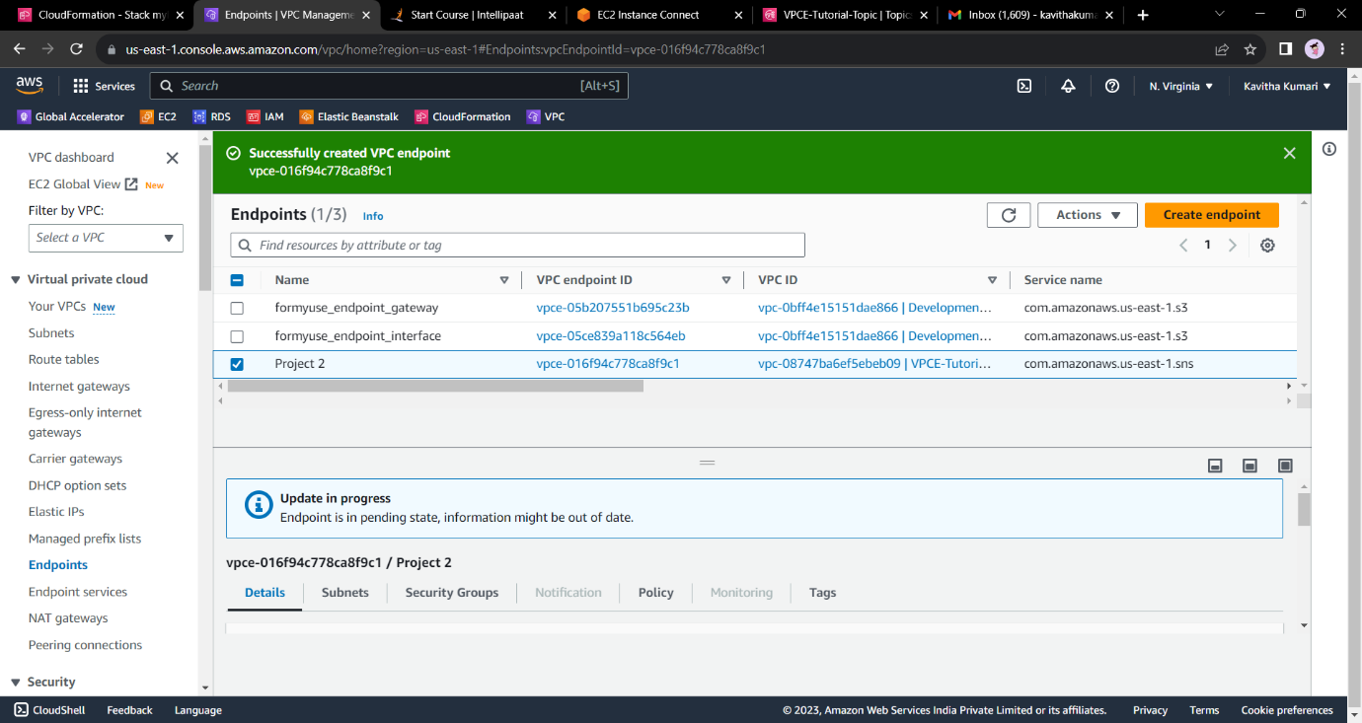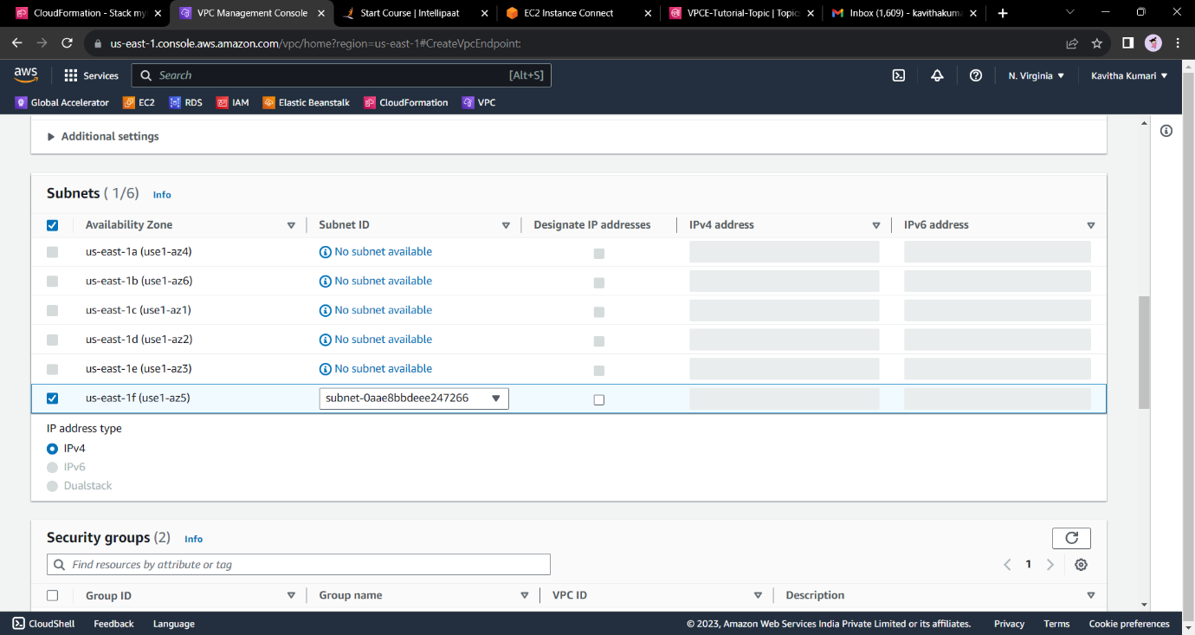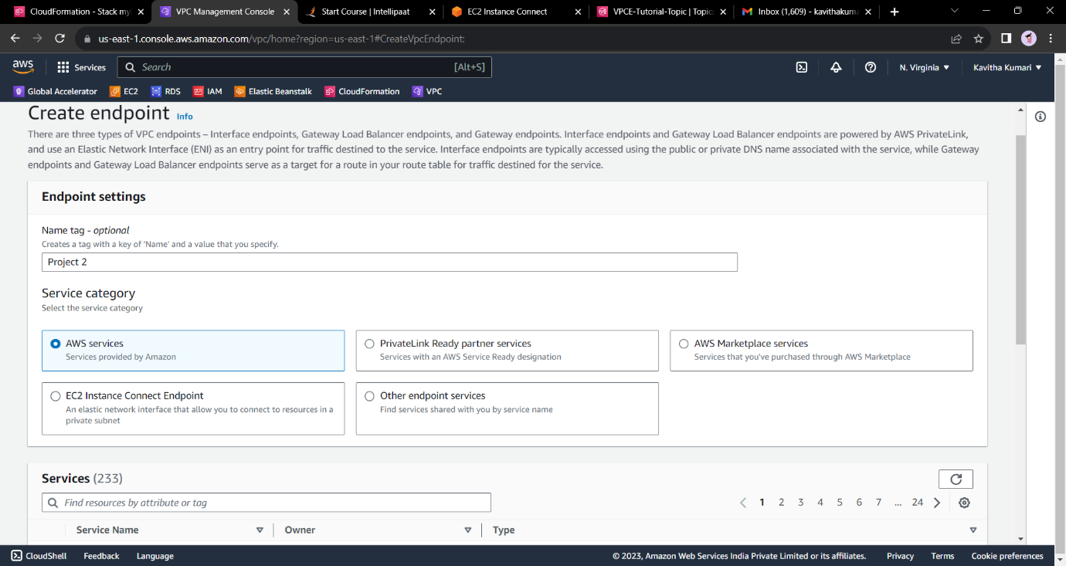For VPC, choose the VPC that has the name VPCE-Tutorial-VPC

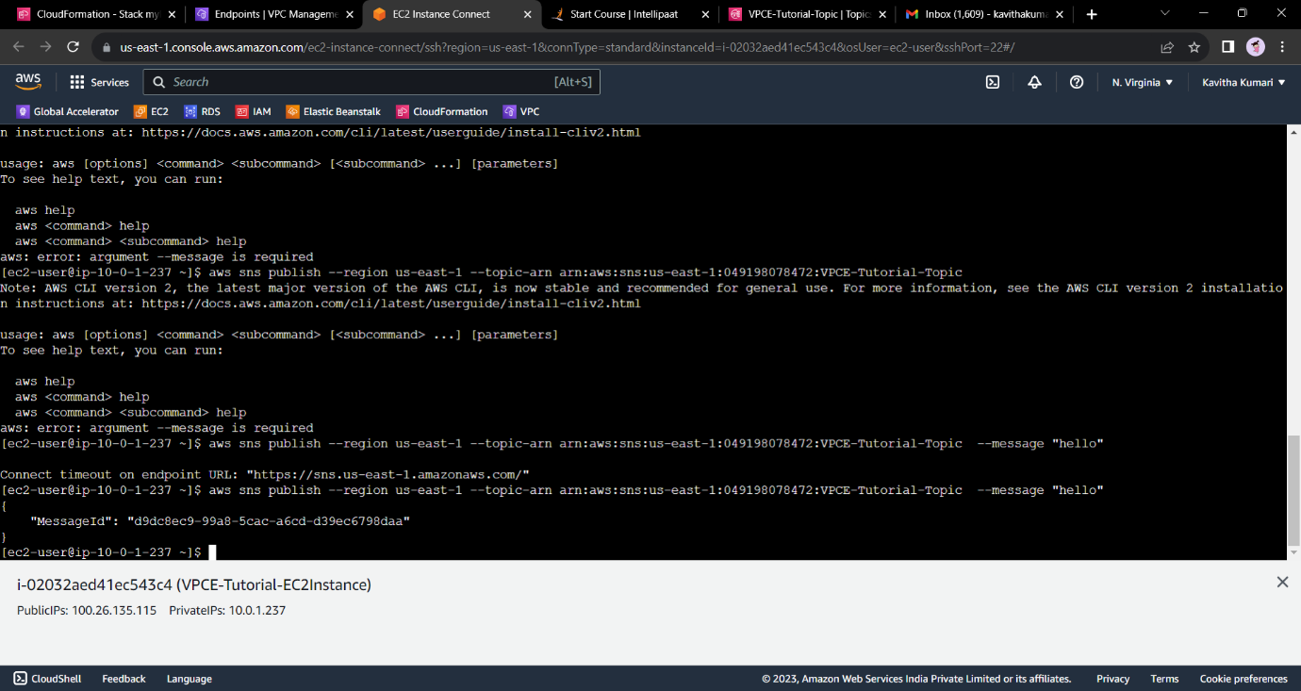

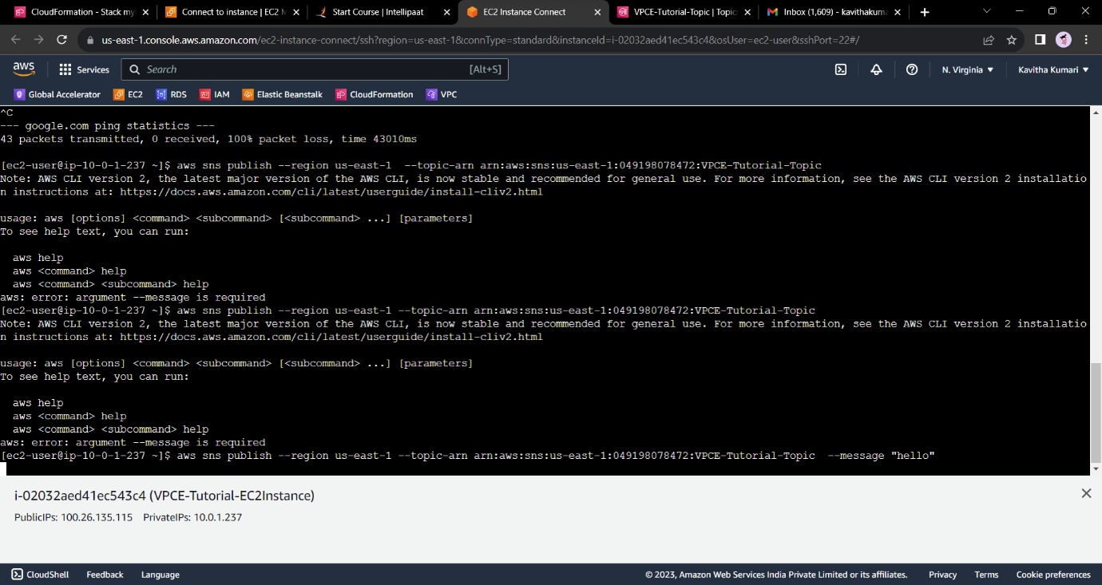

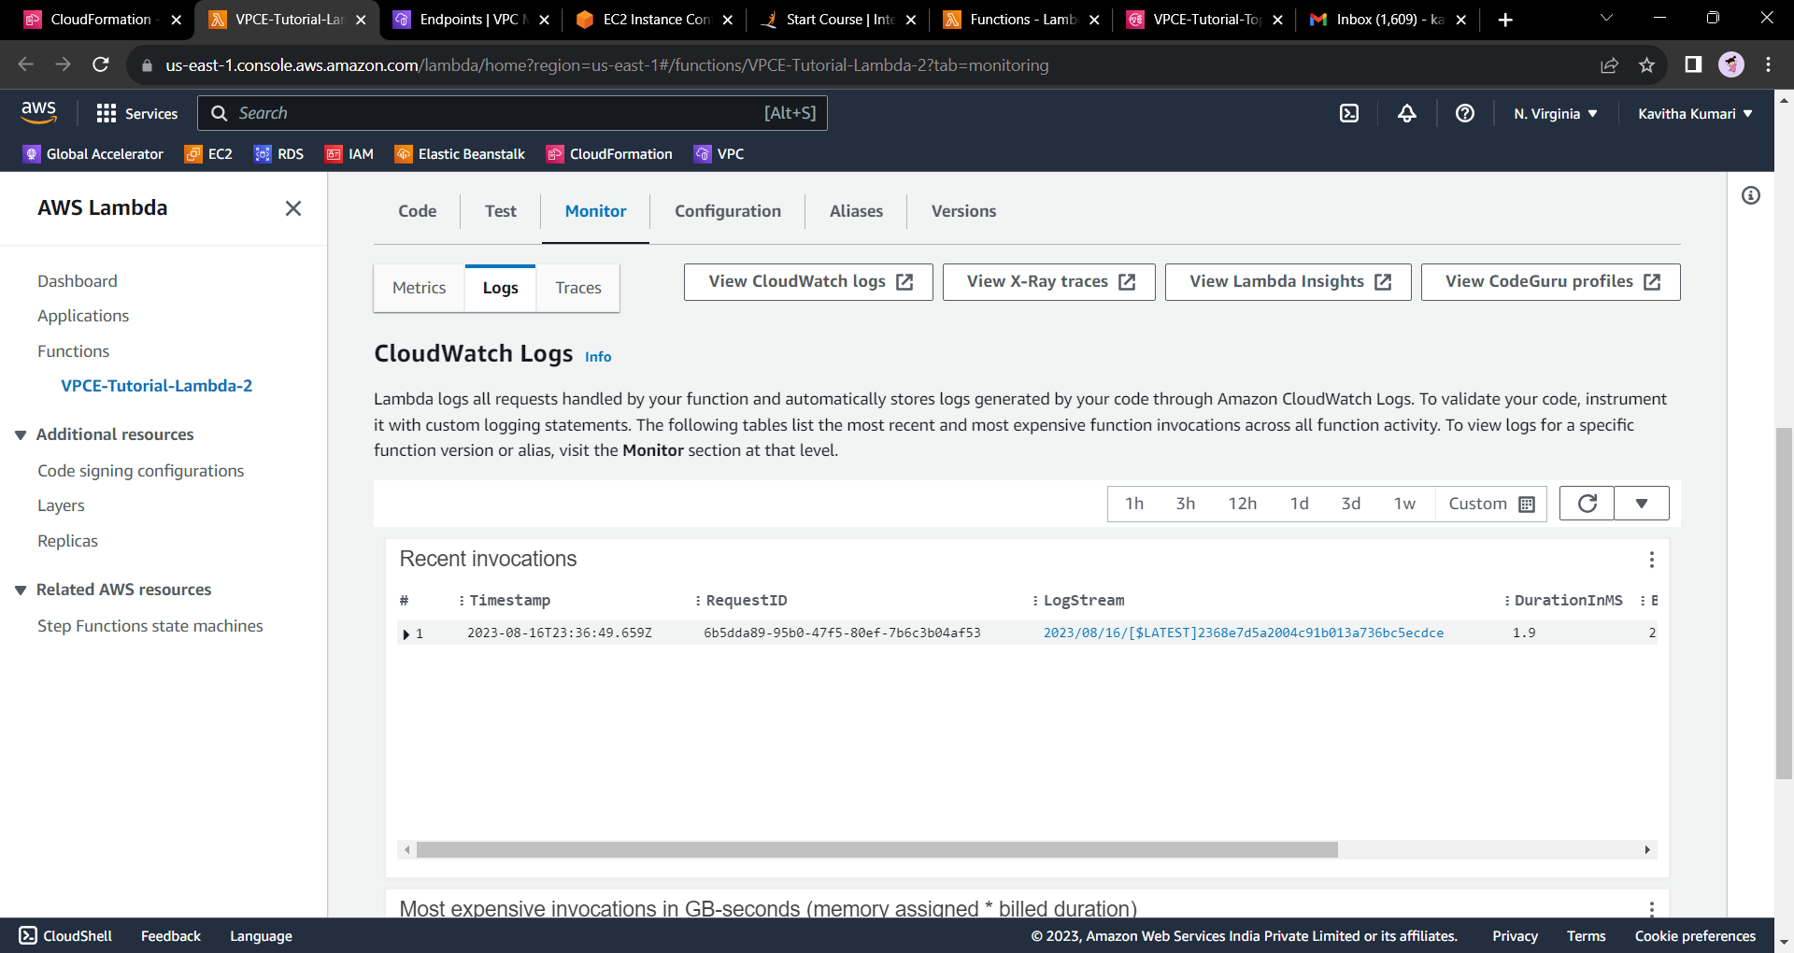

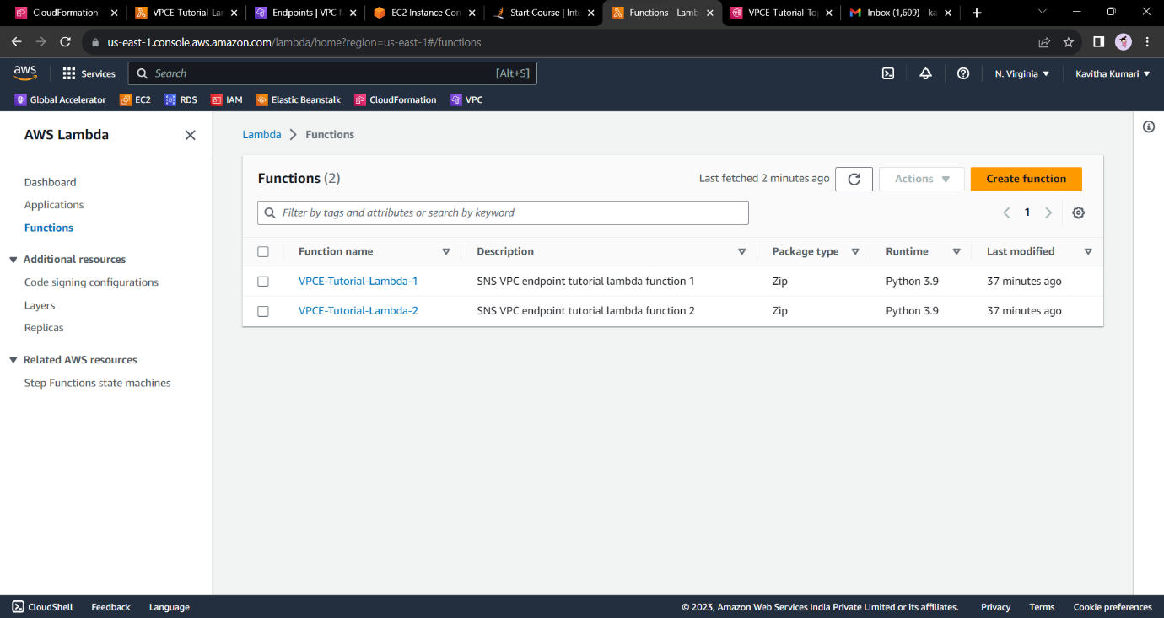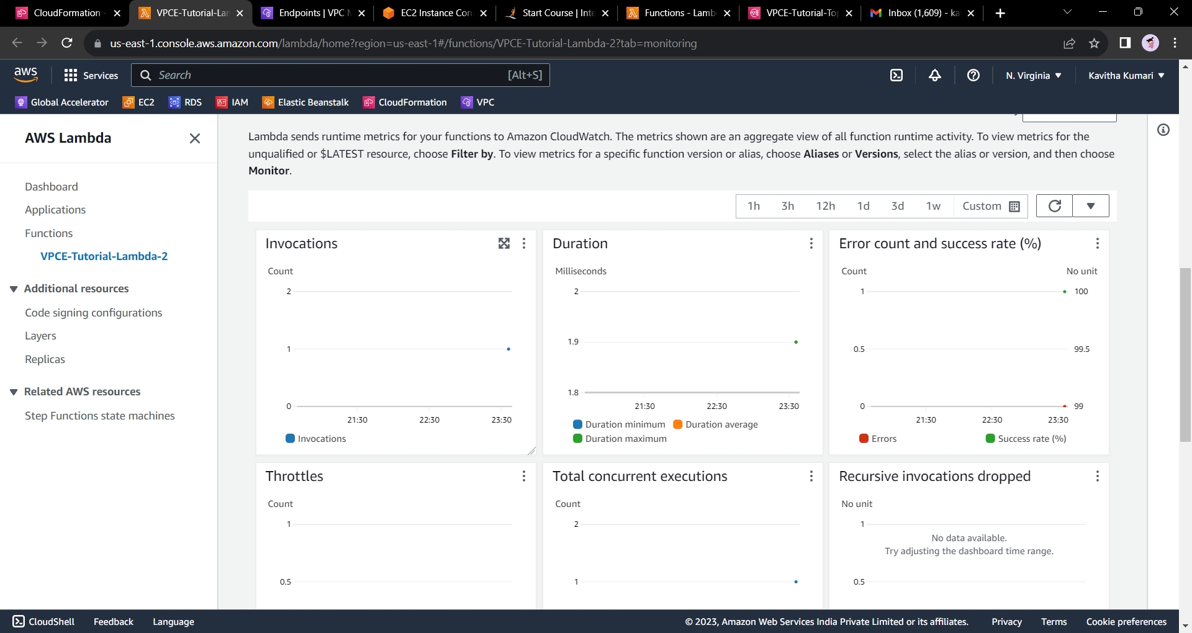

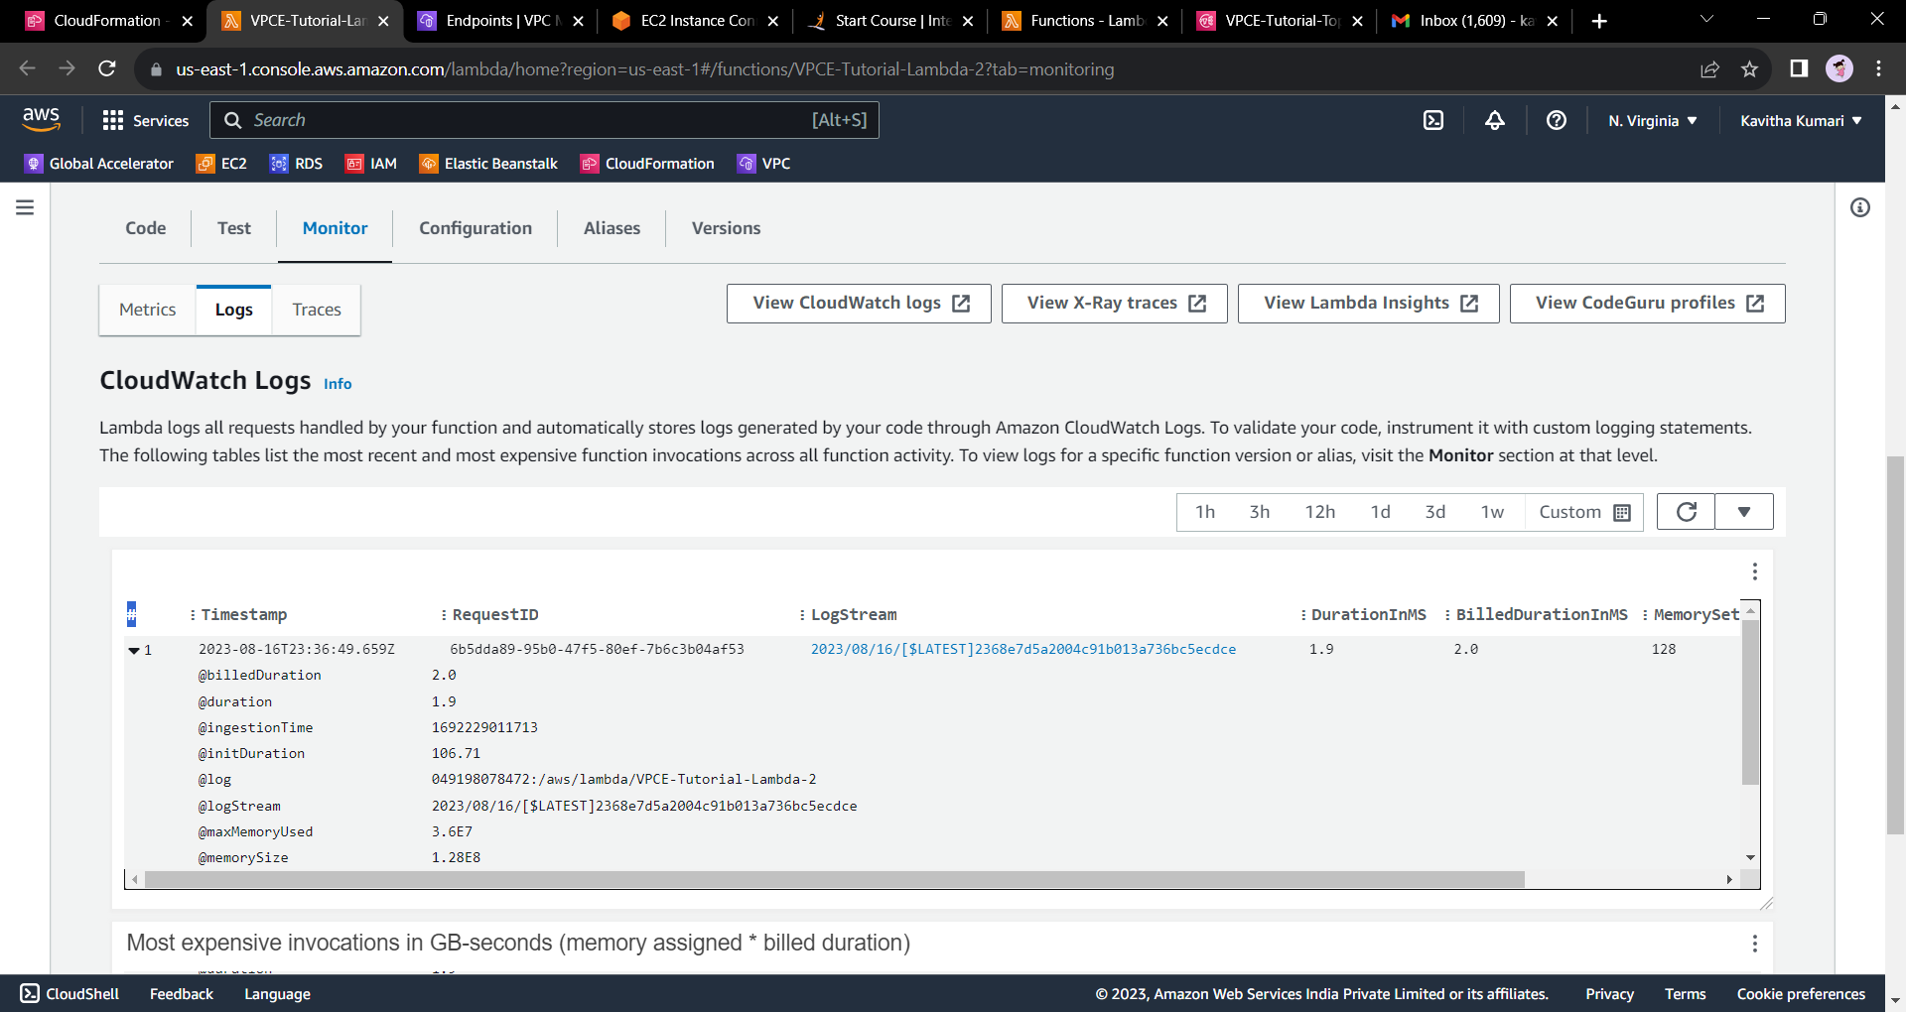

**Click on the log stream to get the below data.**

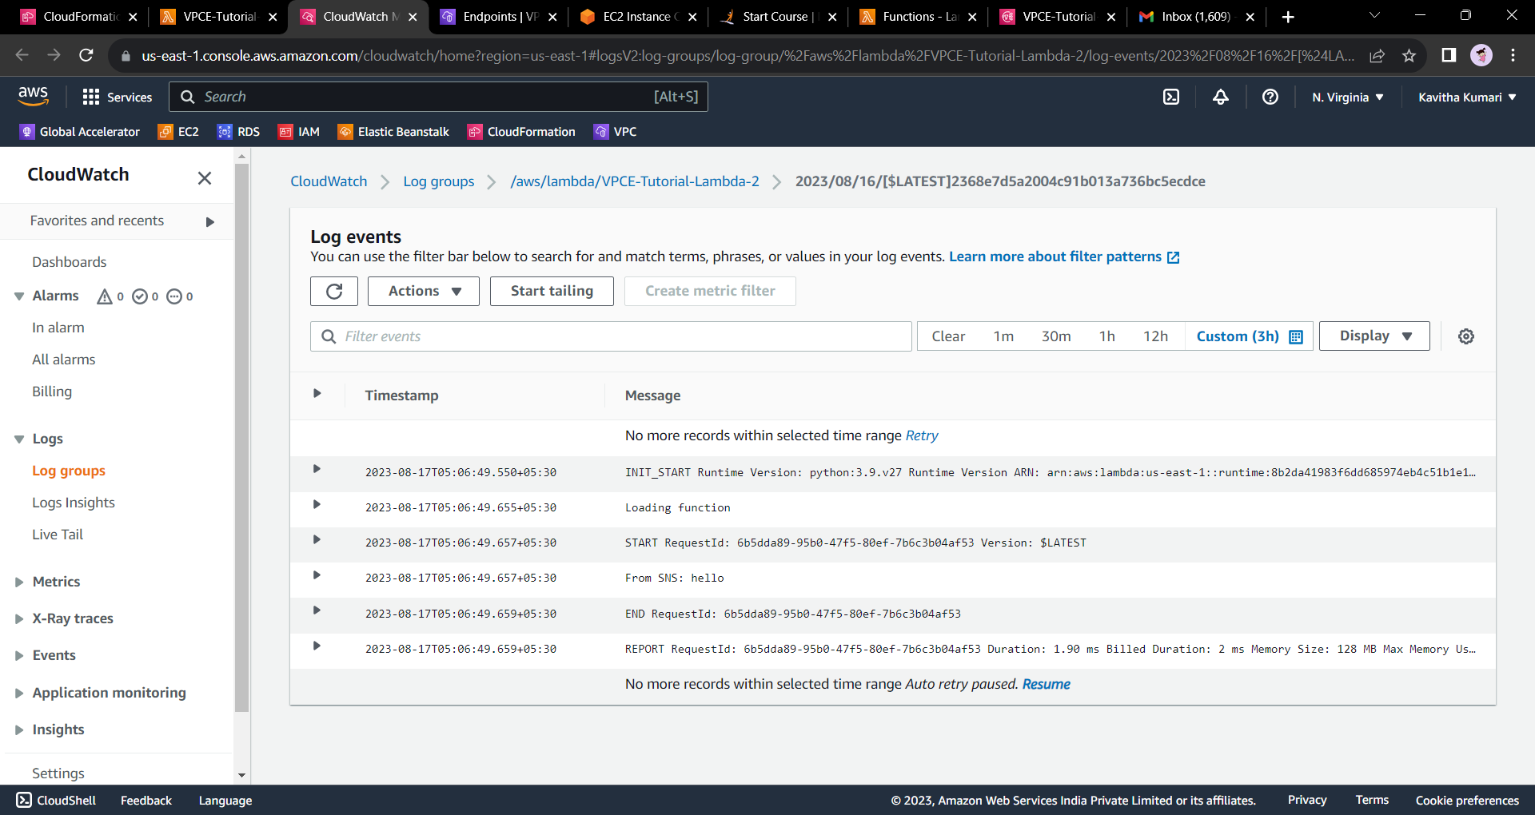

**---End---**